HAMMER STRENGTH ReTail $2500 For Sale $1500

Glute/Ham
The Hammer Strength Glute/Ham offers nuanced design and various adjustments for easy navigation and use.
Product Code: BW-GH
Footprint (D x W x H): 73" x 34" x 51" (metric cm: 188 x 86 x 130)
Weight: 329l(150kg)

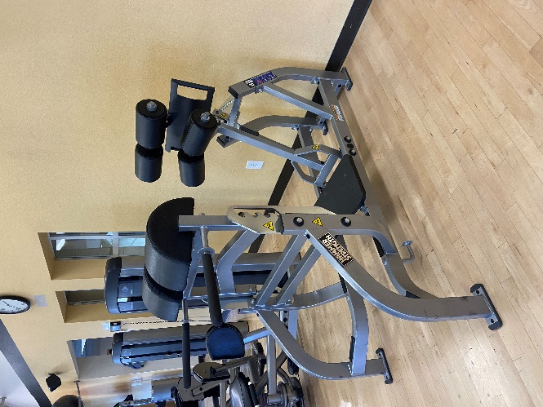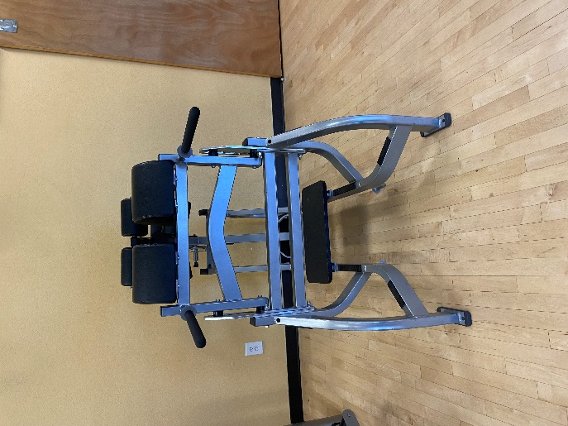
A Glute Ham Developer (GHD) machine is a specialized piece of strength equipment designed to target your glutes, hamstrings, and lower back muscles. The GHD machine allows users to perform a variety of exercises such as glute bridges, hamstring curls, back extensions, and more.

