ROGUE ECHO GYM TIMER -Retails $350 For Sale $150
The standard Echo Gym Timer delivers a single-sided, crystal clear LED display, convenient remote control access, and dozens of pre-set and programmable interval settings for a truly customized experience. The timer can be mounted to a wall or paired with an Echo Floor Stand*. A Two-Sided version of the Echo Gym Timer of the Echo Gym Timer is also available.
Measuring 25.25" x 7.75", the Echo Gym Timer display screen shows the time in red and the number of rounds in green, with bright 4” high numbers that can be seen from several hundred meters away. This makes it easy for a coach, trainer, or gym owner to program the timer for large groups of athletes to use simultaneously.
You can save up to 10 custom programs on the timer at any given time, and the included remote allows individuals to pause, mute or reprogram the device right from their work station. Change the number of rounds, length of rest, and length of work as you see fit, or adjust from a countdown to a count-up option. There are even several unique preset modes available to jump right into, including the Tabata Timer and “Fight Gone Bad” Timer.
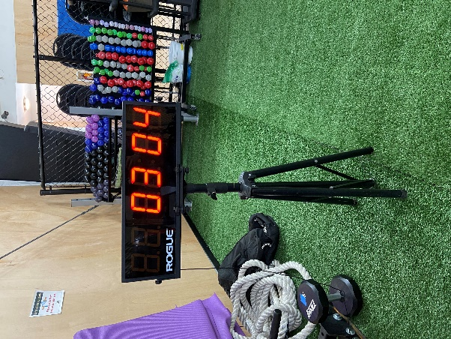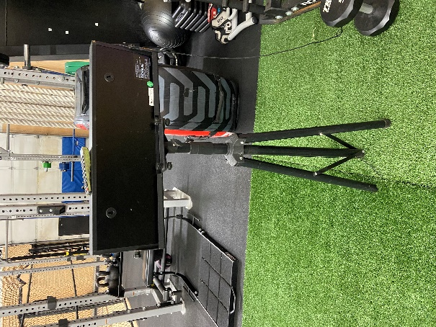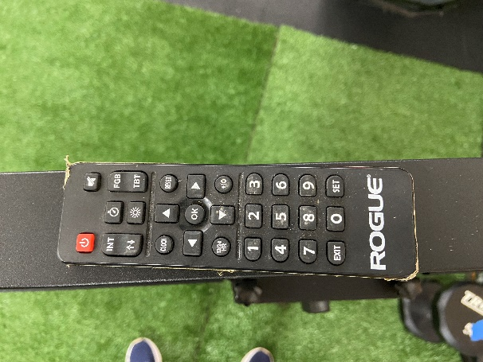

Length | 25.25"
Width | 2"
Height | 7.75"
Other Product Specs | Cord Length - 50"

